**Week 3 Module 5.2 Assignment**

Juan Macias Vasquez

Bellevue University

CSD340-H323 Web Development with HTML and CSS (2261-DD)

**Adam Bailey**

August 31st, 2025

**Module 5.2 BioSite**

**bioSite: Ideas, Sketches, and Inspiration**

**GitHub Repository Link**

<https://github.com/Juan551School/csd-340>

**Chosen Person**

My Sister Jasmine Macias Vasquez

**Biography/Interview (Not Final Version)**

Born in June 25th, 2003 She grew up with her parents, an older brother, and a younger sister most of her life in Colorado with living a few months in Wyoming because of her father’s work.

Jasmine Went to Boston College to study becoming a nurse practitioner. She chose this school due to the full ride scholarship she got even though it was far from home and she would feel home sick every now and then. The first school she went to was out of state in Massachusetts but is now studying at a Redrock’s community college to do some credits before transferring to another University to complete the master’s degree.

Her first pet was a cute half Poodle half Maltese dog named princess who she loved dearly but sadly passed away in summer of 2020. Her current pet is a cat she got as a cute kitten from her friend named Ivy. At first, she thought he was a girl when she got him which is why she named him Ivy.

I always helping at home like taking her younger sister Amy to school and making sure she isn’t late to her college prep courses. Jasmine really Liked Hello Kitty and other cute things, building Legos, doing crafts in her free time, and going to the gym to weightlift and run on the treadmill. Her whole room is decorated in art and crafts or pictures of her with her friend, or her with her sister who she loves spending time with and helping her whenever she needs it.

**Interview Question of My Sister Jasmine**

1. **What is your full name and how do you prefer to be addressed?**

Jasmine Macias Vasquez

2. **Where did you grow up?**

In Colorado

3. **What hobbies or activities are you most passionate about?**

Crafts, Lego’s, Weightlifting, Running

4. **Can you describe a personal accomplishment you’re proud of?**

First Person to Get a college Degree in the family

5. **What inspires or motivates you in your daily life?**

Becoming a better person for myself and for my family, accomplishing big things to make them proud

6. **Who has been the biggest influence in your life?**

My parents because they are very Hardworking, Humble, and Wise

7. **What challenges have you faced and how have you overcome them?**

I am a low income first generation, I overcame this by doing my best to stay on top of my school work so that I can apply and qualify for scholarships, I know there are struggles so I make sure to stay on top of everything so I don’t fall behind.

8. **Do you have any long-term goals or dreams you’re working toward?**

Becoming a nurse practitioner which also means working towards a master’s degree

9. **What’s a fun or little-known fact about you?**

I like to do anything crafting with my extra time

10. **If people could take away one thing about you, what would you want it to be?**

Not giving up through adversity

**Pictures of website pages so Far (Prototypes)**

Colors aren’t final just placeholders

**Landing page (index page)**

Needs picture of her graduating from Boston college under accomplishment 1

Very basic Main page

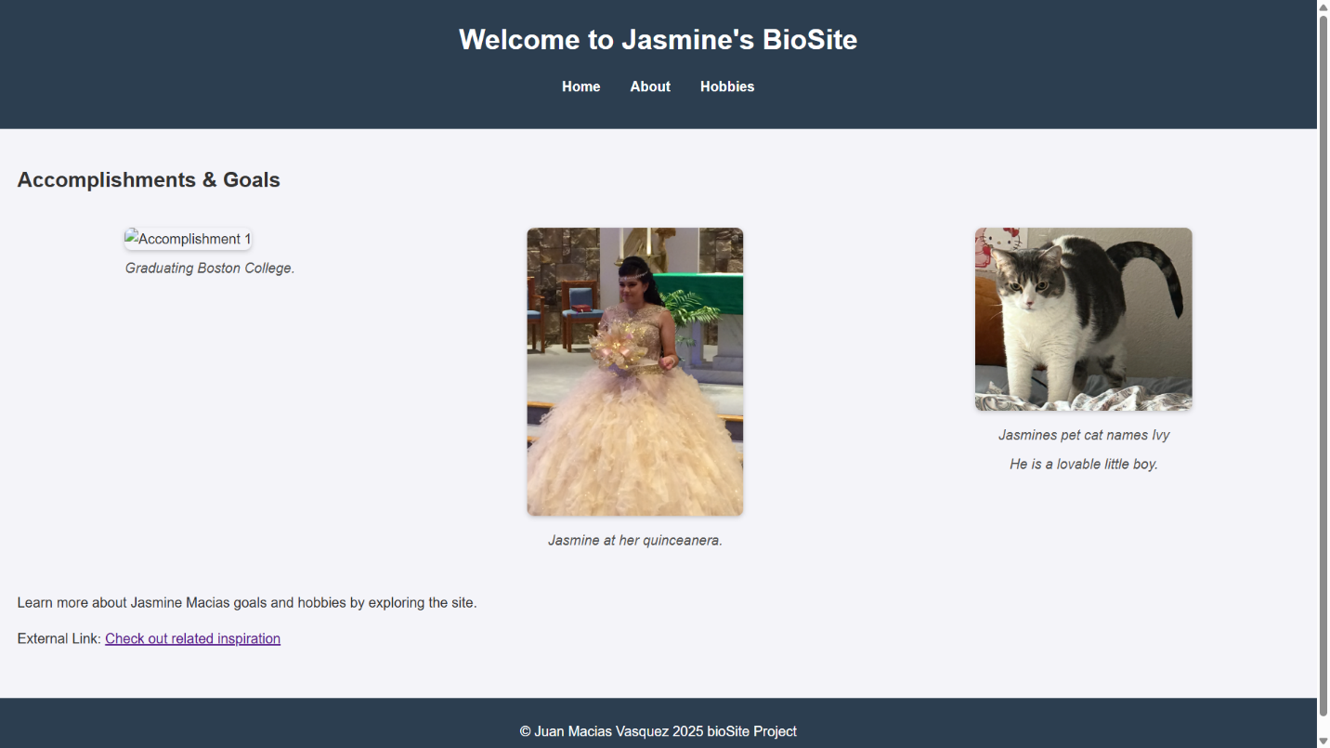

**About page**

Not sure what picture to use yet

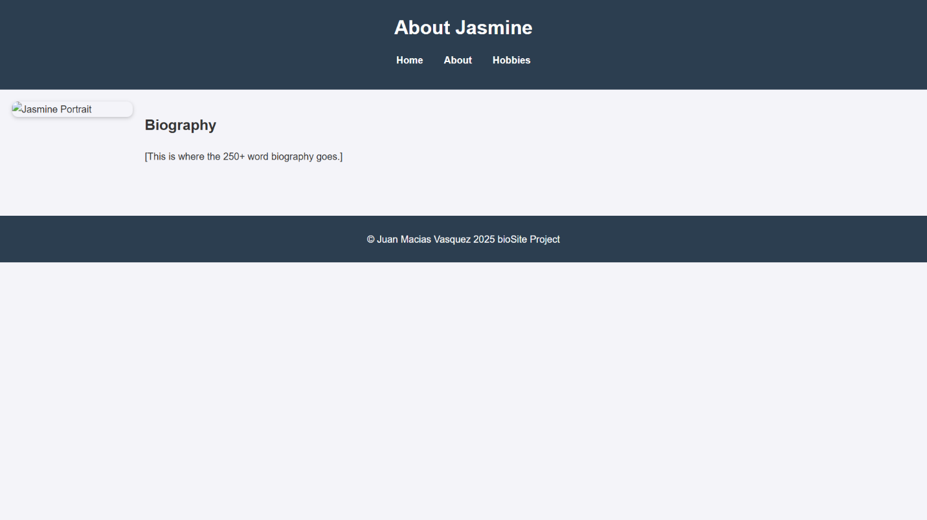

**Hobbies page**

Need to take pictures of my sister involving her hobbies

